**Fall Arrest Protection Systems**

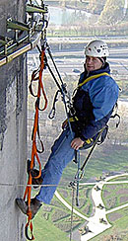**Niko Track Fall Protection Systems**provide a very safe and practical safety system for people working at height. According to OSHA a fall protection system is designed to arrest or prevent falls from a height. OSHA standards state that any time a worker is at a height of four feet or more, the worker is at risk and needs to be protected. Fall protection must be provided at four feet in general industry, five feet in maritime and six feet in construction. However, regardless of the fall distance, fall protection must be provided when working over dangerous equipment and machinery. The US Department of Labor (DOL) lists falls as one of the leading causes of traumatic occupational death, accounting for eight percent of all occupational fatalities from trauma.

**Advantages of Niko Fall Protection Track vs Taut Wire Fall Protection System**

* There is less distance to fall with NikoTrack fall protection track and therefore less impact on the body
* No bouncing effect, which can cause injury on secondary falls
* Multiple person systems are safer with NikoTrack fall protection track. One person falling on a taut wire fall protection systems can cause other users to fall
* Following a fall the Niko fall protection track can be re-used immediately after passing a visual inspection. Taut wire systems need to be completely replaced
* The tapered edge design of the NikoTrack fall protection track achieves very free running movement and eliminates snag effect
* Its modular design means that the NikoTrack fall protection track systems can be easily moved, added to and changed after installation
* NikoTrack fall protection track offers solutions that enable operators to pass each other without detaching themselves from the system
* No length-limit of distance of NikoTrack fall protection track systems
* NikoTrack Fall Protection Systems offer very little interference with workers tasks or activities and will easily/naturally move with the worker
* Because of NikoTracks self aligning trolleys, the safety tether will remain directly above the user, therefore eliminating the possibility of a swing fall
* Because of the enclosed track design, NikoTrack systems are not susceptible to snow, ice, or debris, which allows for year round use of the system

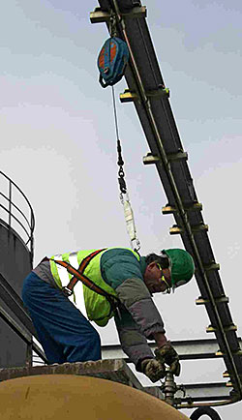

Fall Arrest Features

**Bounce Effect / Secondary Falls**

The biggest fault in traditional taut-wire protection systems is that they do not prevent secondary falls and are prone to what is called the "bounce effect." The bounce effect is caused when the weight of the worker is loaded onto the braided wire (because they fell), causing it to give slightly. The resulting "give" makes the worker fall farther than expected, as well as tightening the wire between other supports, which could cause any one else on the system to fall also. This resulting "bounce" is also known as a secondary fall. A secondary fall is often more damaging to the user than the original fall arrest. Because of NikoTracks rigid design, when a fall occurs the user will only fall as far as the safety tether will let them, there is no secondary fall as there is in a taut-wire system.

**Enclosed Track**

Because NikoTracks fall protection systems are in an enclosed track the hassle of debris jamming the run of the system are completely eliminated. This means that the systems are essentially immune to the elements, allowing for use in any weather condition from blizzard to monsoon. Using a NikoTrack system will enable the user to operate the system year round.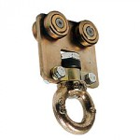

**Tapered Track**

The tapered edges of NikoTracks Fall Protection systems ensure that the load carrying trolleys run smoothly, meaning that the trolley will always be directly above the user, eliminating the dangers of "swing falls." Also, because they are self aligning, **trolleys will always run smoothly and won't jam, even on turns**.

**Reliable & Reusable**

When a fall occurs on a taut-wire system it must be taken out of service temporarily until it has been repaired. Most safety cable system manufacturer's repair procedures require temporary dismantling of the system while a factory-trained professional replaces virtually all of the costly damaged parts. This is not an issue with NikoTracks systems! After a fall a quick visual inspection on the system should be done and upon completion the system can be used again immediately.

**Turns & Switches**

By **combining the turns and switches of our conveyors with the versatility and reliability of the fall protection**, NikoTrack has created an ideal solution to taut-wire systems used on challenge courses. 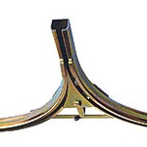These systems have been installed on many pre-existing ropes courses and have greatly increased the overall experience for users as well as creating a safer environment. User are no longer hindered by slow moving trolleys, endangered by secondary falls or wire transfer, and can use the system throughout the year.

Videos

<https://youtu.be/z5PTPTPAgKE>

<https://youtu.be/xfW18Vd9fU4>

Niko Track used for Fall Arrest and Sky Glide in an indoor Adventure Course, Climbing Wall, and High Ropes Course. The Tracking system not only protects the users from falling, but also allows them to ride on the track. *Video provided courtesy of Ropes Course Developments.*

Niko Fall Arrest Track being used for High Ropes Course. *Video supplied courtesy of Ropes Course Developments.*

**NikoTrack Fall Arrest Components**

NikoTrack fall arrest components combine the turns and switches of our conveyors with the versatility and reliability of the fall protection, NikoTrack has created an ideal solution to taut-wire systems. User are no longer hindered by slow moving trolleys, endangered by secondary falls or wire transfer, and can use the system throughout the year.

[](http://nikotrack.com/fallarrest/files/2012/11/Fall-Arrest-System-Manual-May2014.pdf) [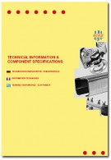](http://nikotrack.com/wp-content/pdfs/C2_Light_weight_Overhead_Cranes.pdf)

|  |  |
| --- | --- |
| **TRACK SERIES** | **SWL / FT** |
| No. 23.000 | 67.0 lbs |
| No. 24.000 | 134.0 lbs |
| No. 25.000 | 335.9 lbs |
| No. 26.000 | 671.9 lbs |
| No. 27.000 | 1075.0 lbs |
|  |  |

**Series 25 / 26 / 27**

**[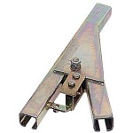](http://fallprotectionsolutions.us/files/2012/11/A05-lg.jpg)**

.A05P  
Left Tongue Switch  
without Bend

**[](http://fallprotectionsolutions.us/files/2012/11/A47-lg-e1353957203381.jpg)**

.A47P  
Single Tongue Switch  
w/ two 90 degree Bends

**[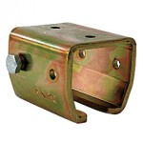](http://fallprotectionsolutions.us/files/2012/11/B00-lg.jpg)**

.B00P  
Support Bracket

**[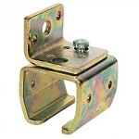](http://fallprotectionsolutions.us/files/2012/11/B01-lg.jpg)**

.B01P  
Wall Support

**[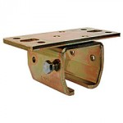](http://fallprotectionsolutions.us/files/2012/11/B02-lg.jpg)**

.B02P  
Ceiling Support

**[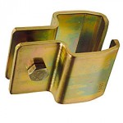](http://fallprotectionsolutions.us/files/2012/11/B03-lg.jpg)**

.B03P  
Split Support

**[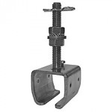](http://fallprotectionsolutions.us/files/2012/11/25.B04P-lg.jpg)**

.B04P  
Height Adjustable

**[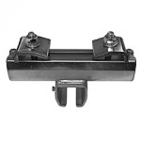](http://fallprotectionsolutions.us/files/2012/11/25.B35P-lg.jpg)**

.B35P  
Adjustable Joist Clamp  
(Parallel)

**[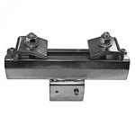](http://fallprotectionsolutions.us/files/2012/11/25.B36P-lg.jpg)**

.B36P  
Adjustable Joist Clamp  
(Horizontal)

**[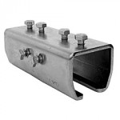](http://fallprotectionsolutions.us/files/2012/11/B49-lg.jpg)**

.B49P  
Track Joint

**[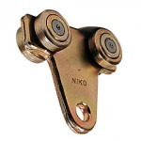](http://fallprotectionsolutions.us/files/2012/11/T10-lg.jpg)**

.T10P  
4-wheel Trolley w/ Hole

**[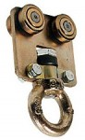](http://fallprotectionsolutions.us/files/2012/11/T40-lg.jpg)**

.T40P  
4-wheel Trolley  
w/ Rotating Eyenut

**[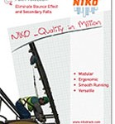](http://fallprotectionsolutions.us/files/2012/11/Fall-Arrest-System-Manual-139.jpg)**